Social Story

Visiting Wellington Museum
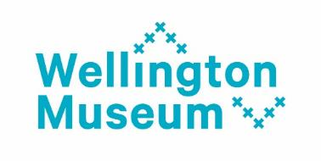

Introduction
We are visiting Wellington Museum.
Wellington Museum is a big building.
There are a lot of different things to see there.
There are four levels inside the Museum with different objects and things on display.
Wellington Museum has a low sensory hour on the first Thursday of the month from 4pm – 5pm. The Museum will be quieter and lights not as bright.
If we visit Wellington Museum during the low sensory hour we can choose to go around the Museum at our own pace or with a Museum staff member.
There might be a group of people with the Museum staff member.
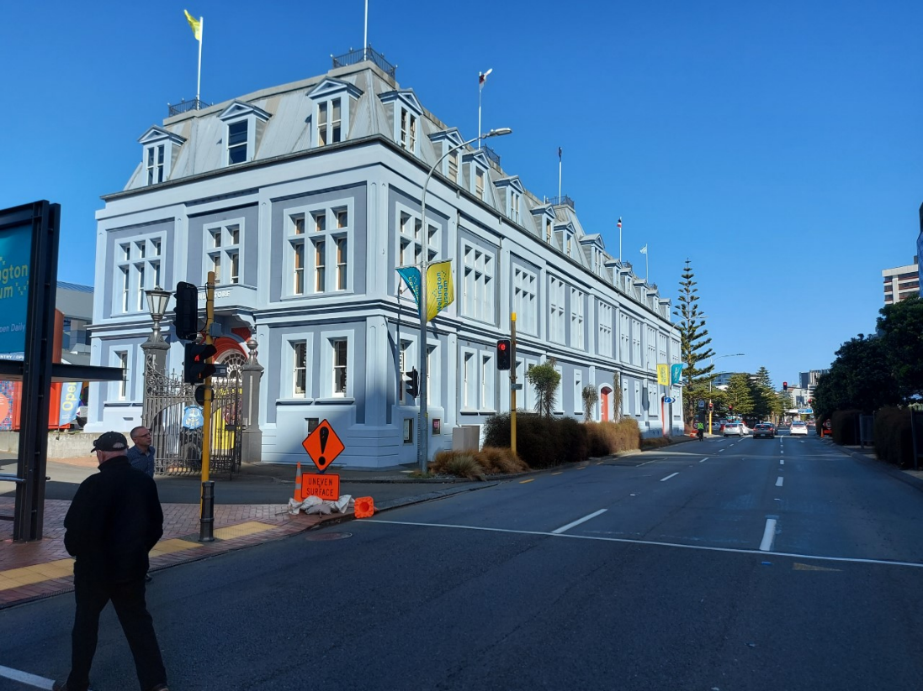
Entering Wellington Museum
When we arrive:
We’ll walk through two sets of sliding glass doors to enter Wellington Museum. The sliding doors open by themselves.
There is a toilet that we can use if we need to. It is after the first set of sliding doors. Staff can show us where it is if we need.
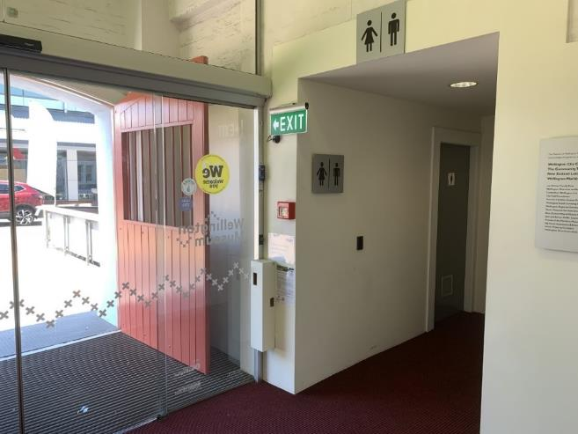
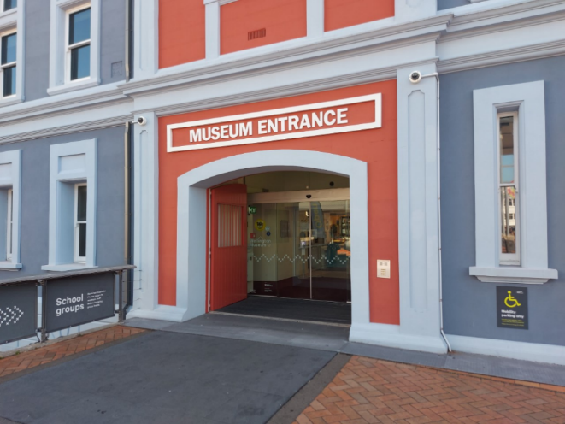

Front Desk
When we enter we’ll see the front desk.
There are helpful staff behind the desk called Visitor Services hosts.
We can pick up a map of the Museum. We can store our coats and bags.
If we have food or drinks we’ll leave those here.
We keep food and drinks away from the exhibition areas because they could damage the objects and displays.
Our belongings will be safe at the front desk.
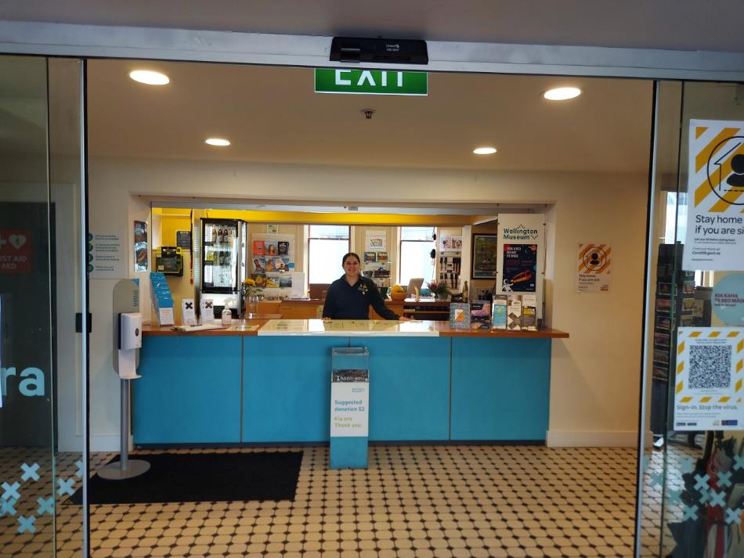
We can collect our belongings when we are ready to leave.

Helpful Staff
We’ll see Visitor Services hosts. They are here to help us.
We might see hosts in the exhibitions wearing black Museum shirts.
It we have questions about the Museum they can help us find the answer.
We can ask where quiet or noisy spaces are.
We might see different hosts each time we visit.

Moving Around the Museum
There are four levels in the Museum.
We can find toilets on the Ground Level by the front desk and in The Attic.
We can go up and down using the lifts or the stairs.
The stairs are in the center of the Museum. The stairs only go as far as Level 2.
The lifts are located through automatic doors on all four levels.
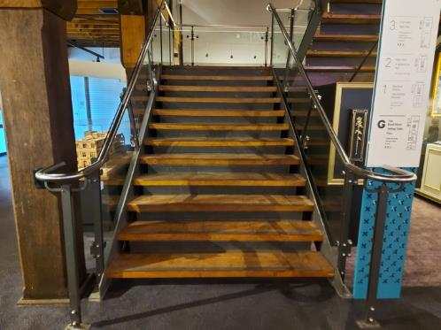
In the lift there is a recorded voice that tells us what level we are on.
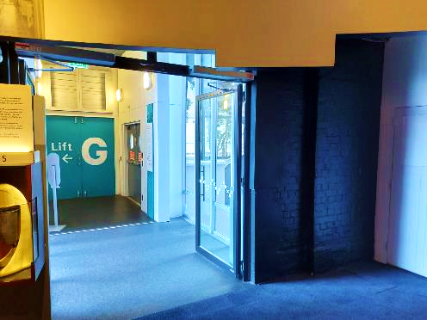
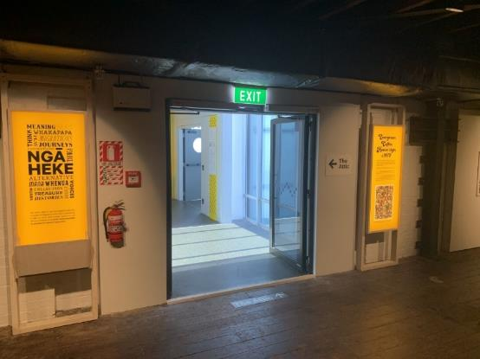
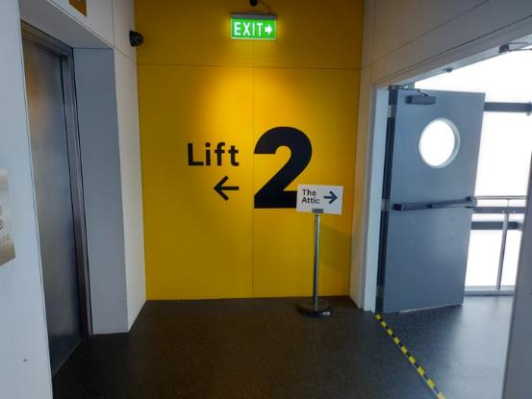
To get from Level 2 to The Attic we use the lift or the stairs opposite the lift.

In the Exhibitions
We’ll see a lot of different objects and things displayed in the exhibitions.
Some rooms may have bright or dim lights.
Some rooms may have displays or things that are noisy.
It’s ok to say if we don’t like something and want to go into a different room.

Entering the First Exhibition
We enter the Museum’s exhibitions through The Bond Store. There is a big blue circle that shows us where The Bond Store starts.
If the blue circle is a bit bright, we can enter The Bond Store through an entrance on the other side of the front desk.
This says exit on the wall, but don’t worry we are allowed to enter this way.
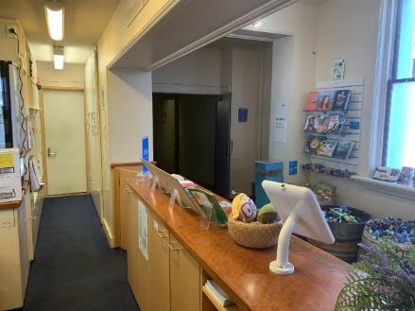
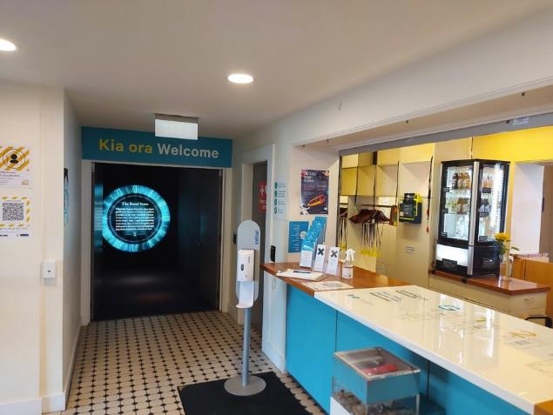

Once we have entered The Bond Store we are inside the part of the Museum where the exhibits are displayed.
Ground Floor
On The Ground Level we’ll find The Bond Store and Te Whanganui-a-Tara.
The Bond Store has a lot of objects that show what things looked like in the 1890s.
Sometimes a fake rat might move along the mast at the back of the room. This rat is on a rail and will not fall down. The rat is watched by a fake cat.
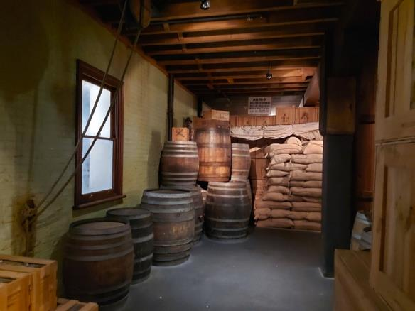

Te Whanganui-a-Tara has carpet showing a map of Wellington.
We’ll see three big murals on the walls.
The exhibition is still being made, so some things on the walls may change.
This is a quiet space for us to walk around and through.
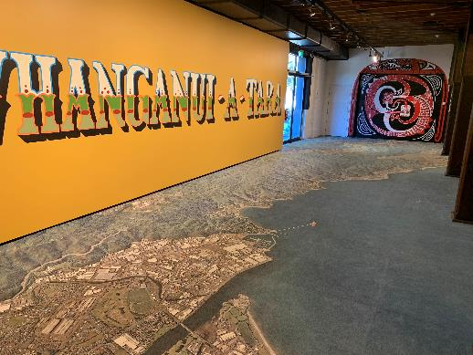

Level 1
On Level 1 we can play in some parts of the exhibition.
We can play with the Captains Wheel in the ship.
There are also some videos with different displays.
We can go inside the Captain’s Cabin.
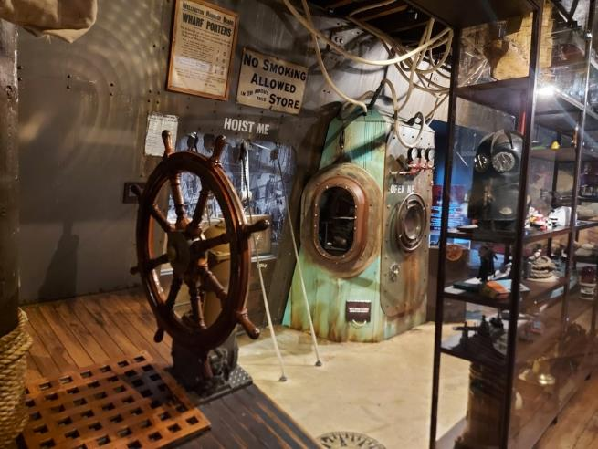
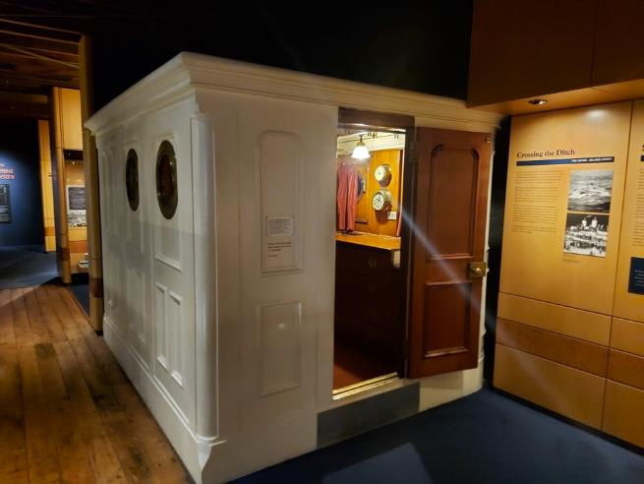
We can see a model of the famous dog, Paddy the Wanderer.

Level 2
We’ll see a lot of different things on Level 2 like the Tuku Tuku Panel.
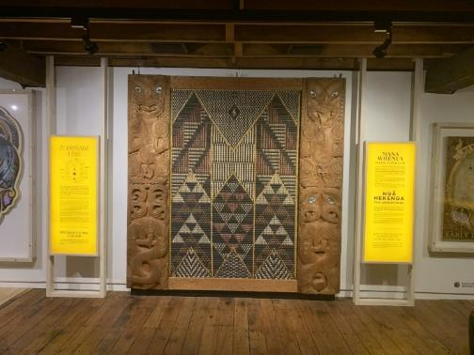

We’ll see a video called A Millennium Ago. This will play at about 4.30pm.
This video tells the story of some Māori Legends.
There are bright lights and loud noises at points during the video.
There is also a trap door on the ceiling that will open suddenly to show a Taniwha.
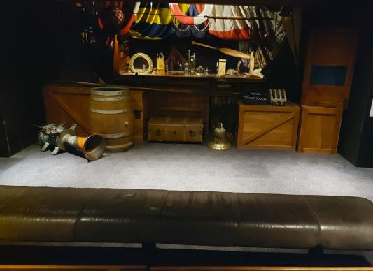

The Attic
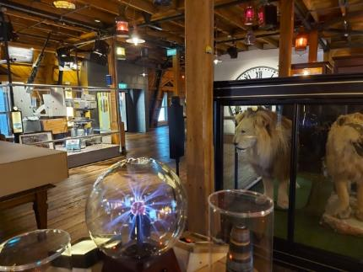
The Attic has a lot of different things to look at.

We’ll see two taxidermy lions. If you press the button you can hear them roar.
Other displays might make noise when you walk past it like the Paper Mache Giant.
We can listen on the old-fashioned phone headsets and hear things about the displays.
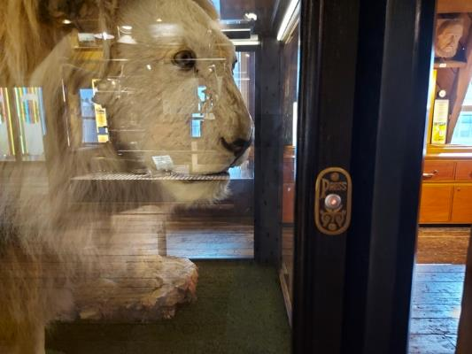
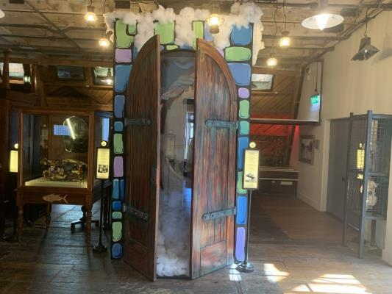

Quiet Zones
There are rooms on Level 1 and The Attic if we would like a quiet space to sit down and relax. When we visit there will be signs showing us the rooms.
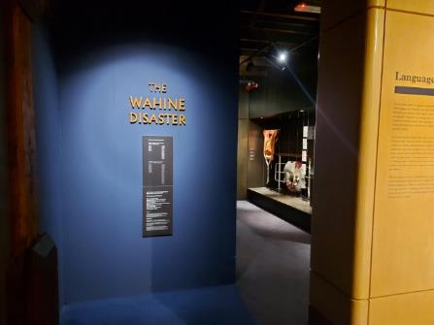
On Level 1 the quiet zone is in the Wahine Disaster. This is a dimmed space where we can sit down. There will be a sign at the entrance to let us know it is a quiet zone.

The quiet zone in The Attic is called the Capital Room. We can close the door and sit down at the table. There is a toilet next to the Capital Room that we can use if we need to.
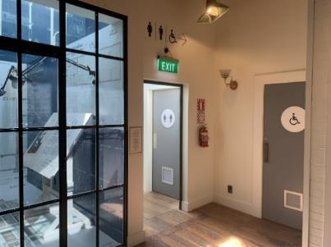
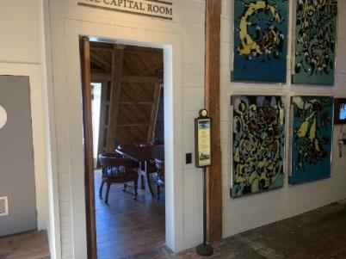

Leaving Wellington Museum
Wellington Museum closes for the day at about 5pm. We can stay in the Museum up until 5pm and then it is time to go.
To leave the Museum we’ll take the lift or the stairs back to the Ground Level.
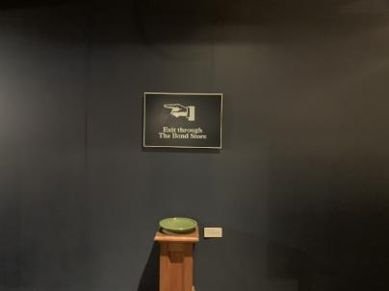
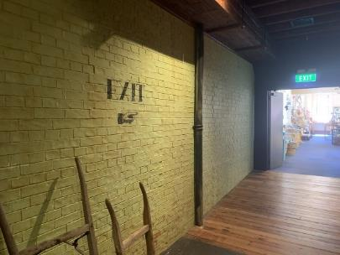
On the Ground Level we’ll go back through The Bond Store to the front desk.

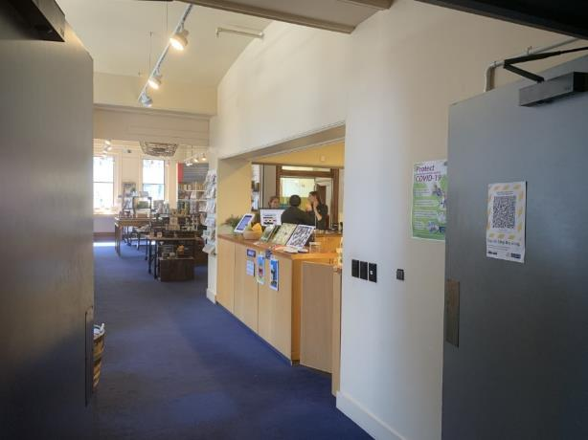

At the front desk we can collect our belongings.
We’ll exit through the two sets of sliding doors that we went through when we entered the Museum.

