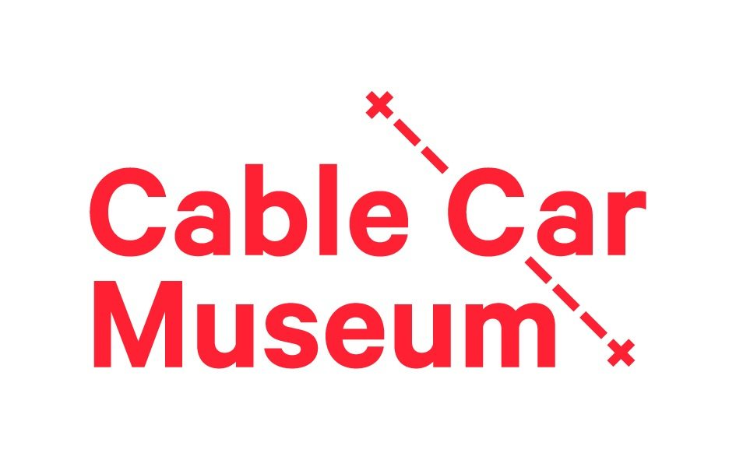
Experience Wellington COVID-19 RAMs for Visiting Education Groups
as at 1 June 2020

RISK | MITIGATION
There are active COVID-19 infections in New Zealand | All Experience Wellington sites follow New Zealand government guidelines
Cable Car Museum educators may infect visitors | Any staff with symptoms do not come to work  Tutors aim to stay 1m away from students
Visitors may infect Cable Car Museum educators | Students, teachers and accompanying adults do not visit if they have any symptoms  Visitors aim to stay 1m away from tutors
Visitors do not know what precautions are in place at Cable Car Museum | Information is issued prior to visit and available on our websites  Visiting groups are met by staff and briefed on COVID-19 precautions before entering the building
Visitors may have touched unhygienic surfaces before entering the building | Students, teachers and accompanying adults sanitise their hands when entering the building  Students are to bring their own personal water bottles and food is to be eaten outside of the premises
Shared areas and equipment may be infected | Cleaning protocols will take place between sessions in all education, public and office spaces
Visitors may have touched unhygienic surfaces during their visit | Hand sanitizer is available in all teaching spaces.  Handwashing is encouraged when appropriate.
In spite of precautions, exposure to COVID-19 happened during a visit | Appropriate contact tracing protocols are in place for groups and accompanying adults. Adults visiting with school group will provide their contact details either a) online prior to the visit, or b) on paper at the start of the visit.  Schools will maintain a register of which students were on site during the visit.  Cable Car Museum would close for cleaning, until permitted to re-open by the Ministry of Health

